1. **Secure Bank Account with Private Data**

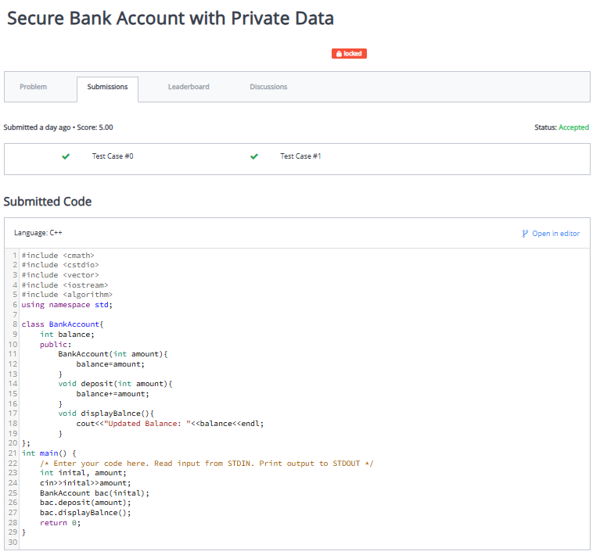

1. **Student Grades with Protected Access**

1. **Private Salary & Public Raise Function**

1. **Vehicle Speed Display System**

1. **Teacher Payroll System**

1. **Employee Attendance Logger**

